Practical 3 Part 3

NAME: TASNEEM SADIKOT
PRN: 23070521162
SEM: 5 SEC: B
1. HTML Form Elements (via DOM)
This is the most common method for user input in web applications. Example:
<input type="text" id="name" />
<button onclick="getName()">Submit</button> <script>
function getName() {
let name = document.getElementById("name").value; alert("Hello, " + name);
}
</script>
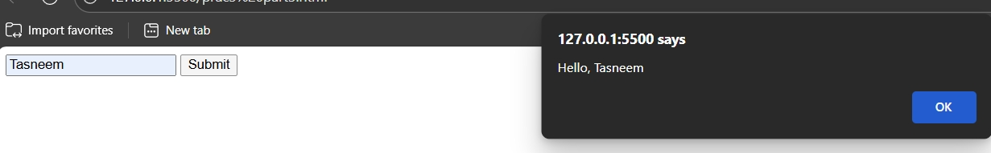

2. prompt() (Browser Dialog Box)
Useful for quick input during testing or simple applications.
let name = prompt("Enter your name:"); alert("Hello, " + name);
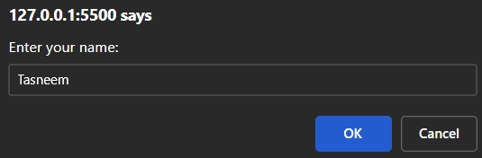
3. Event Listeners (Real-time Input Capture)
You can capture input as the user types using events like keyup, change, etc.
Syntax
document.addEventListener(event, function, Capture)
<input type="text" id="liveInput" placeholder="Type something"> <p id="display"></p>
<script>
document.getElementById("liveInput").addEventListener("keyup", function() {
document.getElementById("display").innerText = this.value; });
</script>
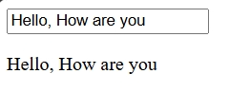
4. Form Submission with submit Event
Ideal for processing form data in a structured way.
<form id="myForm">
<input type="number" name="marks" />
<button type="submit">Submit</button>
</form>
<script>
document.getElementById("myForm").addEventListener( "submit", function(e) {
e.preventDefault(); // Prevent reload
let marks = this.marks.value;
alert("Marks entered: " + marks);
});
</script>
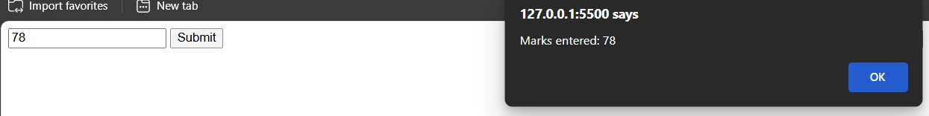
5. File Input (Read File Data)
Used when the user uploads a file.
<input type="file" id="fileInput">
<script>
document.getElementById("fileInput").addEventListener( "change", function() {
const file = this.files[0];
alert("Selected file: " + file.name);
});
</script>
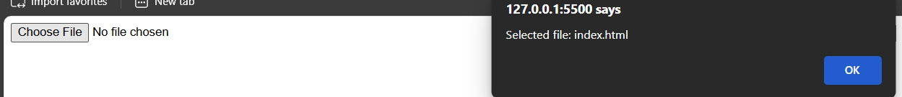
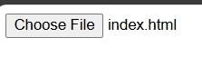
6. URLSearchParams (Query Parameters)
If values are passed through the URL.
const params = new
URLSearchParams(window.location.search); const name = params.get('name'); // ?name=John

Task:
Create a grading system that classifies grades based on marks entered by the user.
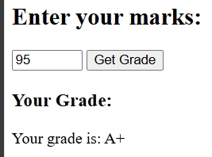
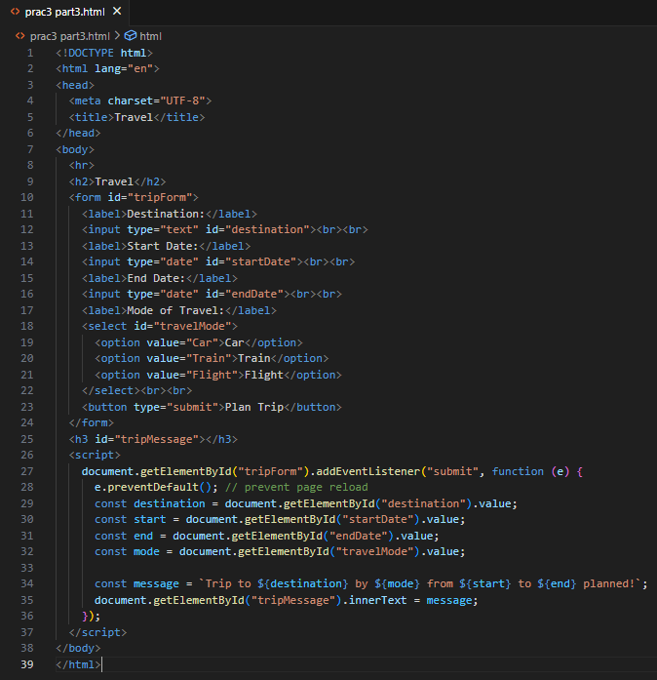

Task1:
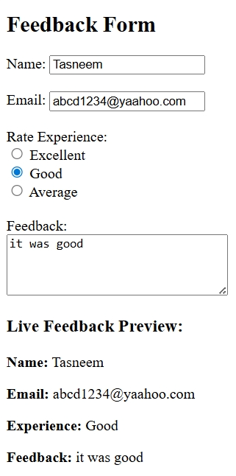
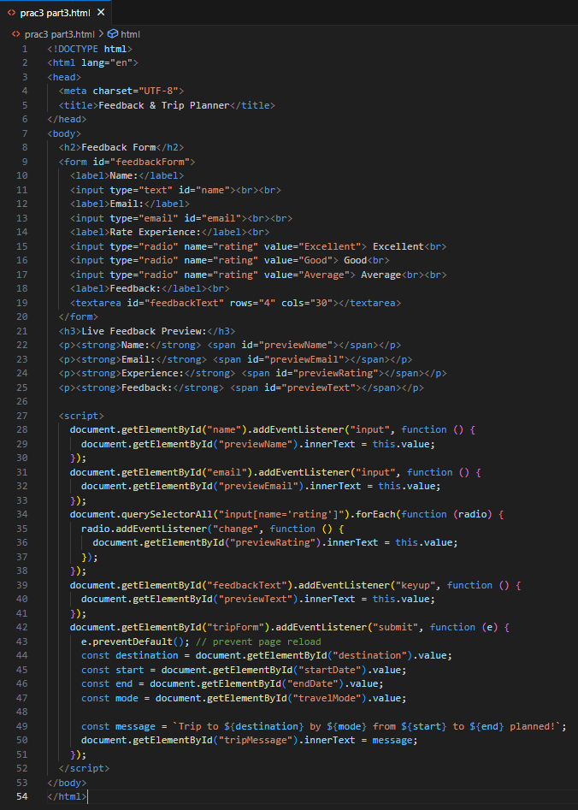

Task2:
